Order Of Service

Singing: Psalm 119b—CW page 110

Reading: Psalm 93

Opening Hymn: TLH 38

Reading: Acts 17:16-28

Request Hymn: CW Supplement 749

Reading: Matthew 6:19-21

Sermon Hymn: TLH 39

Sermon Text: Mark 4:13-20

The Sower And The Seed

Prayer

The Apostles’ Creed, TLH page 12

Holy Communion

The Lord's Prayer

The Blessing

Closing Hymn: TLH 46

* * * * * * * * * * *
Bible Study: Lambs: White Pine
Sheep: Proverbs 16:16-20
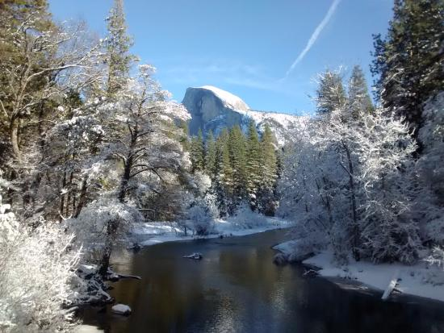

Winter In Yosemite National Park

Water
Of
Life

17 February 2019

W A T E R O F L I F E

Independent Christian Church—Conservative Lutheran Doctrine

Worship Service: 9:30 a.m. Bible Study: 10:45 a.m.

Larry Cooper, Pastor E-Mail address:
111 N. Ridge Road lcooper@wateroflife.cc
Coon Valley, WI 54623 Web Site:
www.wateroflife.cc

* * * * * * * * * * * * * * * * * * * * * * * * * * *

Sermon Text: Mark 4:13-20

The Sower And The Seed

* * * * * * * * * * * * * * * * * * * * * * * * * * *

Mark 4:13 And he said unto them, Know ye not this parable? and how then will ye know all parables?
:14 The sower soweth the word.
:15 And these are they by the way side, where the word is sown; but when they have heard, Satan cometh immediately, and taketh away the word that was sown in their hearts.
:16 And these are they likewise which are sown on stony ground; who, when they have heard the word, immediately receive it with gladness;
:17 And have no root in themselves, and so endure but for a time: afterward, when affliction or persecution ariseth for the word's sake, immediately they are offended.
:18 And these are they which are sown among thorns; such as hear the word,
:19 And the cares of this world, and the deceitfulness of riches, and the lusts of other things entering in, choke the word, and it becometh unfruitful.
:20 And these are they which are sown on good ground; such as hear the word, and receive it, and bring forth fruit, some thirtyfold, some sixty, and some an hundred.

* * * * * * * * * *

Related Reading: Isaiah 55:8-13

8 For my thoughts are not your thoughts, neither are your ways my ways, saith the LORD.
9 For as the heavens are higher than the earth, so are my ways higher than your ways, and my thoughts than your thoughts.
10 For as the rain cometh down, and the snow from heaven, and returneth not thither, but watereth the earth, and maketh it bring forth and bud, that it may give seed to the sower, and bread to the eater:
11 So shall my word be that goeth forth out of my mouth: it shall not return unto me void, but it shall accomplish that which I please, and it shall prosper in the thing whereto I sent it.
12 For ye shall go out with joy, and be led forth with peace: the mountains and the hills shall break forth before you into singing, and all the trees of the field shall clap their hands.
13 Instead of the thorn shall come up the fir tree, and instead of the brier shall come up the myrtle tree: and it shall be to the LORD for a name, for an everlasting sign that shall not be cut off.

